Figure S1. Category-Specific Calibration Plots
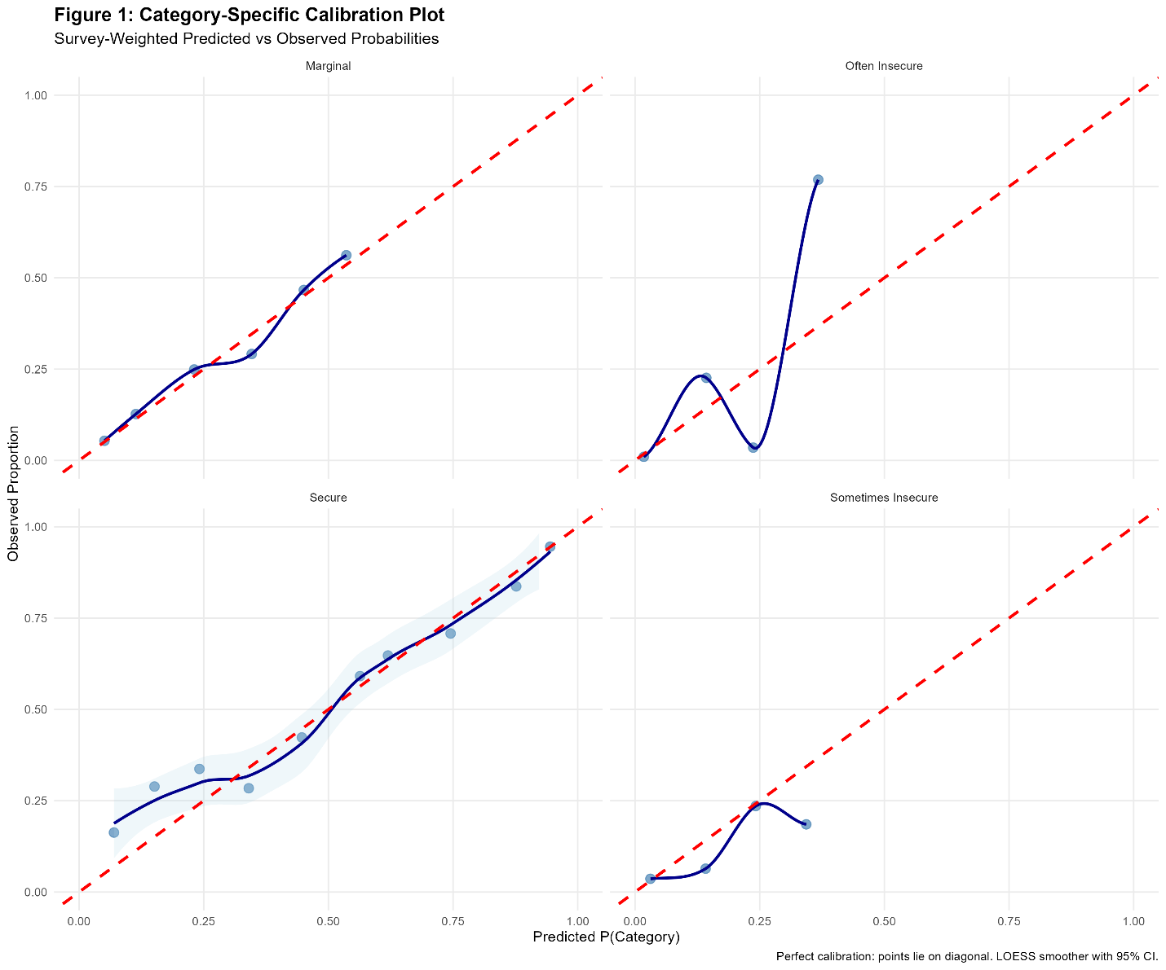

Figure S2. Predicted Probabilities of Food Insecurity Levels by Expense Difficulty
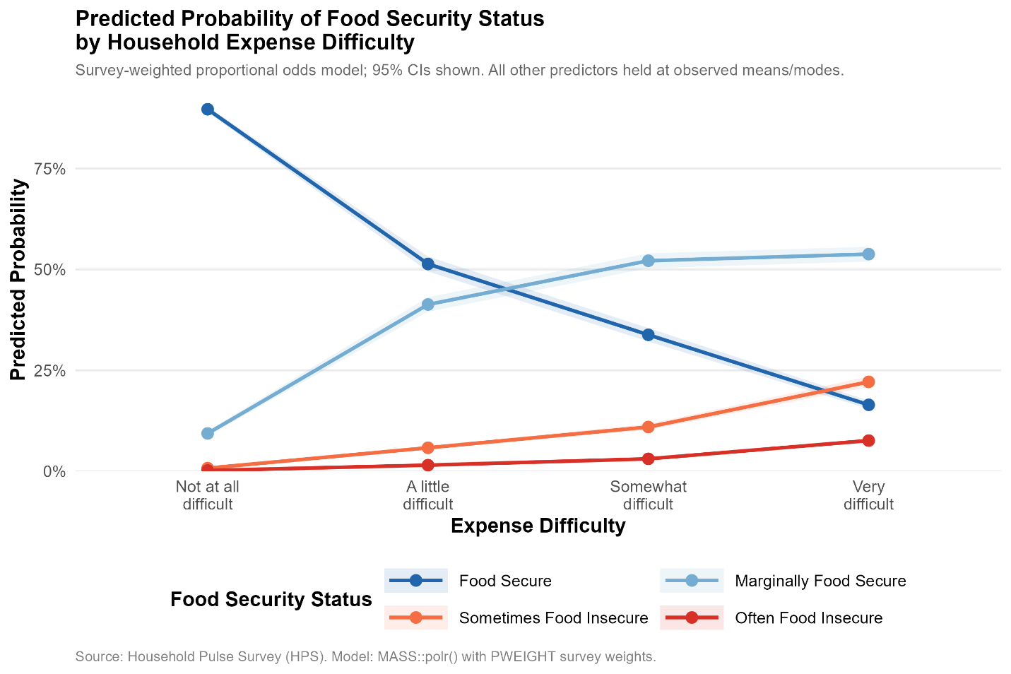

Table S1. Risk Stratification of Food Insecurity and Assistance Coverage Based on Survey-Weighted Predicted Probabilities at 70th percentile
Group | Weighted N | % of Population | Mean Risk Score | % Receiving Assistance
Not High-Risk | 47,795,975 | 70.0% | 0.028 | 31.2%
High-Risk + Assistance | 14,460,366 | 21.2% | 0.259 | 100.0%
High-Risk + No Assistance | 6,048,964 | 8.9% | 0.208 | 0.0%

Table S2. Risk Stratification of Food Insecurity and Assistance Coverage Based on Survey-Weighted Predicted Probabilities at 90th percentile
Group | Weighted N | % of Population | Mean Risk Score | % Receiving Assistance
Not High-Risk | 61,434,669 | 89.9% | 0.049 | 35.8%
High-Risk + Assistance | 5,560,351 | 8.1% | 0.403 | 100.0%
High-Risk + No Assistance | 1,310,286 | 1.9% | 0.355 | 0.0%

